**A PROJECT REPORT ON**

**COMPUTATIONAL PHYSICS**

**“DESIGN AND DEVELOPMENT OF PLASTIC PYROLYSIS”**

**Submitted by**

SANGGIT SAARAN K C S (CB.SC.U4AIE23247)

SURYA HA (CB.SC.U4AIE23267)

VISHAL SESHADRI B (CB.SC.U4AIE23260)

VENKATRAM KS (CB.SC.U4AIE23236)

HARIVAARTHAN TD (CB.SC.U4AIE23228)

In partial fulfilment for the award of the degree of BACHELOR OF TECHNOLOGY CSE(AI) Under the Guidance of Dr. **Akhil Mohan** Centre for Computational Engineering and Networking AMRITA SCHOOL OF ARTIFICIAL INTELLIGENCE AMRITA VISHWA VIDYAPEETHAM COIMBATORE - 641 112 (INDIA)



AMRITA SCHOOL OF ARTIFICIAL INTELLIGENCE AMRITA VISHWA VIDYAPEETHAM COIMBATORE - 641 112 (INDIA)

**ACKNOWLEDGEMENT**

We hereby declare that this thesis entitled “**DESIGN AND DEVELOPMENTOF PLASTIC PYROLYSIS”,** is the record of the original work done by our team under the guidance of Dr. Akhil Mohan Assistant professor, Centre for computational engineering and Networking Amrita school of Artificial Intelligence, Coimbatore. To the best of our knowledge this work has not formed the basis for the award of any degree/diploma/associate ship/fellowship/or a similar award to any candidate in any university.

**Signature of the Faculty:**

**Project Team:**

**Name (Roll Number)**

1. SANGGIT SAARAN K C S (CB.SC.U4AIE23247)
2. VISHAL SESHADRI B (CB.SC.U4AIE23260)
3. SURYA HA (CB.SC.U4AIE23267)
4. VENKATRAM K S (CB.SC.U4AIE23236)
5. HARIVAARTHAN T D (CB.SC.U4AIE23228)

**Place**: Coimbatore

**Date:**

**TABLE OF CONTENTS**

**CONTENTS PAGE NO.**

1. Abstract…………………………………………………………….1
2. Introduction……………………………………….….….………...3
3. Literature review…………………………………………………..4
4. Pyrolysis: An overview…………………………………….……...6
5. Process flow diagram……………………………………………...8
6. Material and methods……………………………………….……..9
7. Design requirements…………..….……………………………….10
8. CAD Diagram ……...…………………………………….……….12
9. Work Methodology …………………………………….…………14
10. Factors affecting pyrolysis…………………………….………......16
11. Feedstocks…………………………………………….…………..20
12. Obtained products and its Application…………….……..……......22
13. Pyrolysis kinetics…………………………………….……………23
14. Advantages and disadvantages of pyrolysis…...…….....………….25
15. Economic and environmental impact………………...…......…….27
16. Results and analysis……………………………….………………30
17. Limitations……………………………………………..………….31
18. Contributions……………………………………….……………..32
19. Conclusions………………………………………….…….……....33
20. Future scopes…….………………………………….……...….….36
21. Timeline…………………………………....……………………...38
22. References…………………………………………………..……39
23. **ABSTRACT**

Over the past few years, plastic pollution has become an increasingly pressing issue, demanding innovative solutions to effectively manage waste. This report delves into the economic perspective of plastic pyrolysis as a sustainable solution to tackle the global plastic crisis. By utilizing cutting-edge technologies and taking into account social, economic, and environmental factors, our research aims to provide a thorough analysis of the potential and obstacles involved in implementing plastic pyrolysis. Additionally, this study introduces plastic pyrolysis as a promising method for transforming plastic waste into valuable resources such as fuel, chemicals, and other reusable materials.

With the increasing global problem of plastic waste build-up, it is vital to find innovative solutions to minimize its environmental impact. In this study, we explore the creation of an advanced plastic pyrolysis system to tackle this issue by turning plastic waste into valuable hydrocarbons. This process offers a sustainable method for producing fuels and raw materials for the petrochemical industry, providing economic benefits. Our research focuses on how the composition of plastic waste affects the resulting product yields and properties during pyrolysis. Notably, the addition of polyethylene (PE) leads to higher levels of alkanes, while polystyrene (PS) contributes to an increase in aromatic content. Furthermore, polypropylene (PP) acts as a catalyst for alkene formation, and both PS and PP have a positive impact on the process

The main objectives of the "Design and Development of Plastic Pyrolysis” report is to explore and present a comprehensive study on the implementation of a novel plastic pyrolysis system that incorporates a double condenser mechanism for maximizing the oil products, and to design a continuous pyrolysis apparatus as a semi-scale commercial plant. The report aims to achieve the following specific objectives:

The study focused on understanding of the thermal cracking process and the reactor design to produce high quality Bio oil from pyrolysis. Conduct an in-depth analysis of the technical aspects involved in the design of a plastic pyrolysis system with a double condenser system and identifying key factors that affect the pyrolysis process. Explore the principles of pyrolysis and assess how the incorporation of a double condenser enhances the efficiency of the process.

Investigate and optimize the plastic pyrolysis process to maximize the yield of valuable products, such as Bio oil and chemicals, through the utilization of a double condenser setup. Explore how the double condenser mechanism contributes to minimizing environmental impacts compared to conventional pyrolysis methods.

A continuous pyrolysis apparatus was designed and manufactured based on the results and the information collected from the work performed during the first two stages. By addressing these objectives, the report aims to contribute valuable insights into the design and development of an advanced plastic pyrolysis system with a double condenser mechanism, emphasizing its technical, economic, and environmental implications of such a system

1. **INTRODUCTION**

Today plastics have become an indispensable element of our day-to-day life in a modern society. They are necessary for such practical activities as agriculture, car production, electricity and electronics, construction materials, packaging, etc. Even though incorrect placement of plastic waste or low recycle rate and the fact that plastic does not degrade biologically have resulted into growing amount of generated plastic waste mainly in rich countries. Therefore, steps should be put in place to avert some environmental implications that would emanate from the disposal of plastics in large quantities which include serious ecological issues.

While managing the biomass and plastic waste, two main approaches are widely practiced – landfilling and incineration. These are also known to be accompanied by a set of corresponding ecological problems. Therefore, it becomes unfeasible for landfilling as there are technical considerations, local opposition, leakage and soil contamination, and unknown environmental implications of plastic degradation. Secondly, the organic constituent of plastic cannot be recovered through land filling and this is critical in view of the scarcity of the world petroleum reserves.

Burning may generate some energy but leaves the organic component of plastic waste as carbon dioxide (CO2) and water (H2O). Burning will depend on the type of plastic but this process also releases pollutants like hydrocarbons, NOX, dust, dioxin, as well as other toxic substances, destroying the surrounding ecosystem. Plastic cannot be biodegraded, and although most petroleum-based products resist this process, it is still not a solution.

Another way of dealing with plastic waste could be via pyrolysis. Thermal degradation of plastic residue takes place at moderate temperature and pressure (about 400 degrees C and 3.5 MPa) under inert atmosphere. The resulting pyrolysis products are small intermediate species. Pyrolysis unlike destructive processes, helps in recovering value added reaction products which can be used as fuel or raw material in various industries. The resulting gaseous and liquid products during pyrolysis depend on the type of plastic waste being utilized. This study is centred on examining the influence of the composition of plastic waste on yield and product composition

1. **LITERATURE REVIEW**

1. Plastic Waste-to-Pyrolysis Conversion Technologies:

Comprehensive review on innovate technologies and pyrolysis process for converting plastic waste into useful resources. Pyrolysis is an environmentally sound alternative, in response to the environmental challenges brought forth by the plastic menace.

2. "Review and Design Overview of Plastic Waste-to-Pyrolysis Oil Conversion with Implications on the Energy Transition" by Moses Jeremiah Barasa Kabeyi and Oludolapo Akanni Olanrewaju: An overview of the design in the study conducted by Durban University of Technology and the energy transition implication of the plastic waste pyrolysis process. For example, it provides an insight to the technological and engineering aspects of pyrolysis as an eco-friendly substitute.

3. "Re-Design Pyrolysis Reactor Prototype for the Conversion of Plastic Waste into Liquid Fuel" by Arizal Aswan, Irawan Rusnadi, Fatria, Zurohaina, Rima Daniar: Sriwijaya’s polytechnic research regarding the practical perspective of a prototyped pyrolysis reactor design. The study is in regard to engineering challenges and the development of efficient plastic waste conversion technologies.

4. "Pyrolysis technology for plastic waste recycling: “A state-of-the-art review” by centre for Biorefining, University of Minnesota: A detailed review compiling information and critically assessing the present stage of pyrolysis technology for plastic waste disposal. This review offers useful perspectives on technological considerations and obstacles in plastic waste recycling via pyrolysis.

5. "Economic and Environmental Assessment of Plastic Waste Pyrolysis Products and Biofuels as Substitutes for Fossil-Based Fuels" by Antonio Espuna, Universitat Politècnica de Catalunya: This study assesses the economic and environmental ramifications of pyrolysis products and biofuels from plastic waste. It offers a broad view on the sustainability of these fuels as well as their suitability as replacements for fossil fuels.

6. "Studies on Fire Pyrolysis and Modelling For Plastics" by VSRS SARMA SALAGRAMA, IIT Roorkee: Plastic fire pyrolysis and modelling research from Indian Institute of Technology Roorkee. In this regard, the study offers the initial fundamental knowledge for effective pyrolysis and considers the modelling issues with respect to the various sorts of plastics.

7. "Pyrolysis Of Waste Plastic into Fuels" by Feng Gao, University of Canterbury: This paper is mainly concerned with the practical aspects of waste plastic pyrolytic fuel production. It most probably considers some difficulties associated with certain kinds of plastic and ways towards understanding conversion.

8. "Journal of Analytical and Applied Pyrolysis" by Yi Cheng, Aston University: This journal also features research that offers interpretations of the pyrolysis process. The research may, therefore, involve the elaborate scrutiny of pyrolysis by-products that give out the chemical and molecular structure information about the converted substances.

Together, these literature sources provide a comprehensive view of complexities involved in plastic pyrolysis waste to energy conversion, engineering perspectives, environmental and economic analysis, and case studies.

1. **PYROLYSIS: AN OVERVIEW**

Plastic pyrolysis is a process that involves the thermal decomposition of plastic waste in the absence of oxygen. This process breaks down plastic materials into smaller hydrocarbon molecules, which can then be used as feedstock for various applications, such as fuel production or chemical manufacturing.

* 1. **PLASTIC PYROLYSIS**

The production of plastics has been increasing and led to a lot of accumulation of plastics in many places which has finally caused many environmental problems. The increase in plastics finally led in the depletion of fossil fuels and finally it made it difficult for the generation of petroleum. Though recycling and other processes were undertaken for plastics the process was very tedious and therefore researchers diverted the case of reversing the process, called pyrolysis. As petroleum was the major source of plastic manufacturing, researchers tried to bring back oil back from the plastics Oil produced by pyrolysis has high calorific value that compared with the regular fuel.

* 1. **HISTORY OF PYROLYSIS**

Pyrolysis, the decomposition of organic materials at high temperatures without oxygen, has a long history. Ancient civilizations like the Greeks and Romans used heat to extract valuable substances from wood and other organic materials, even though they didn't fully understand the process. One of the oldest and most widespread uses of pyrolysis is in charcoal production, where wood is heated in the absence of oxygen to create carbon-rich charcoal. The natural process of coal formation, which takes millions of years, can also be considered a type of pyrolysis. During the Industrial Revolution, pyrolysis was harnessed for various applications, including the production of coal gas for lighting and heating. In the 19th century, pyrolysis became integral to petroleum refining, enabling the cracking of hydrocarbons to produce lighter fuel fractions. The development of synthetic polymers in the early 20th century utilized pyrolysis to create materials like rubber and contributed to the advancement of synthetic polymers such as nylon and polyester. In recent decades, pyrolysis has gained attention as a waste management and resource recovery technique, converting organic waste like plastics, tires, and biomass into valuable products like biochar, bio-oil, and syngas. Today, researchers are actively working on optimizing pyrolysis for sustainability and efficiency, making it a key component of the circular economy.

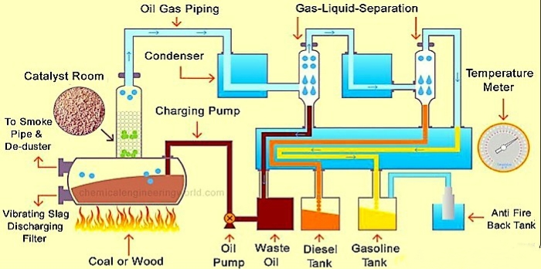

Fig 4.1 Schematic Diagram Industrial process of Pyrolysis

**4.3 PROCESS FLOW DIAGRAM**

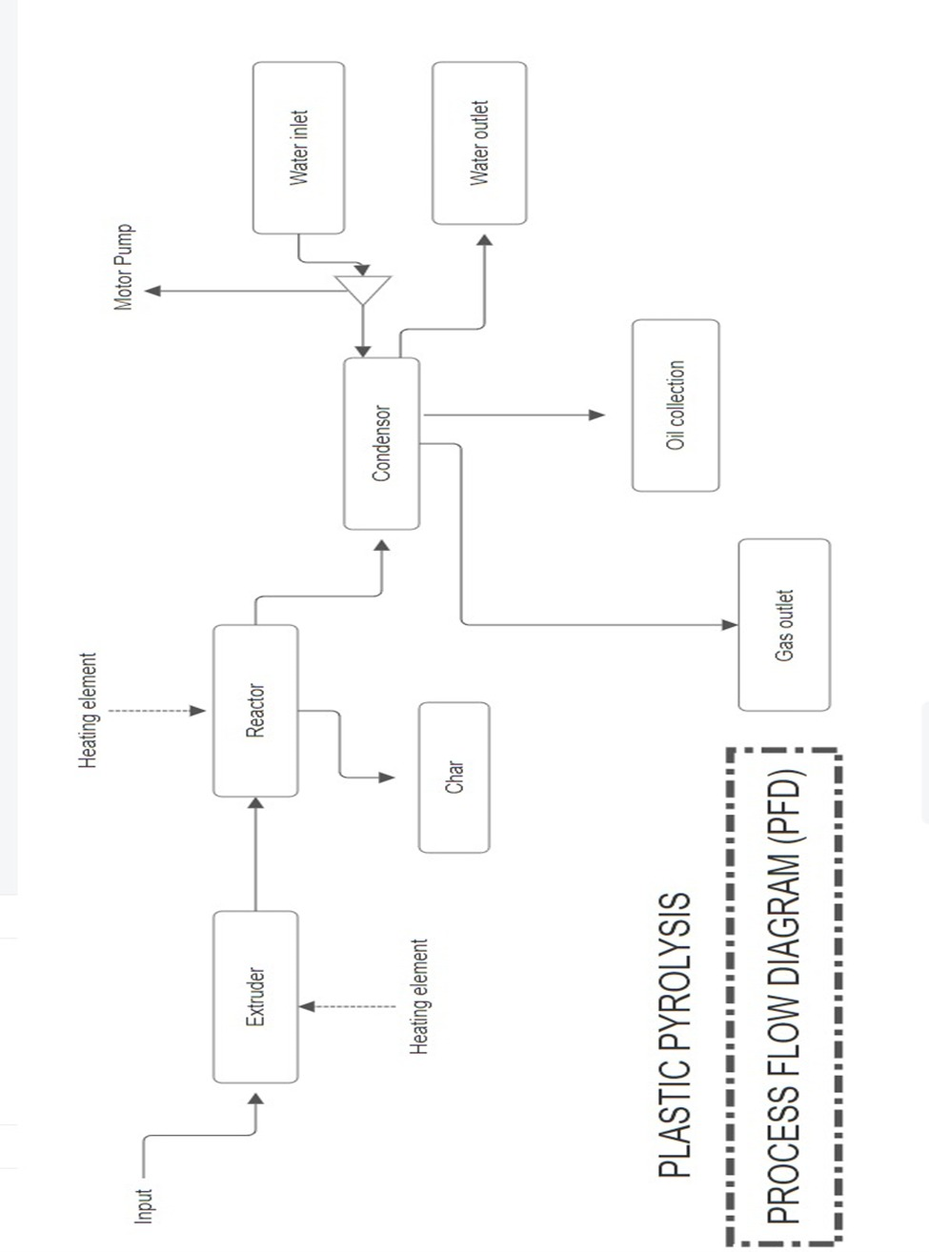

Fig 4.3 Process flow Diagram of Plastic Pyrolysis

the process flow diagram serves as a backbone for our project. A PFD shows the conditions of the inputs, outputs, and at every step in between. Many calculations have to be done in order to ensure that this diagram is as accurate as possible. As stated above, this PFD serves as the backbone for the project and is referred to by all that are involved in order to communicate the proper conditions and so that the team is acting as one. Any new finding causes an immediate update to the PFD to ensure that the team is up to date. Figure __ below shows the PFD for the designed plastic pyrolysis setup.

The input feed is first added into reactor, with use of extruder the feedstock is heated and sent into condenser. The condenser condenses the vapours and oil gets collected collecting flask. The water is pumped into the condenser from one side to another to condense the vapour, water the comes out from outlet. Hence, the char gets collected in reactor the harmful gases are released-out.

1. **MATERIALS AND METHODS**
   1. **MATERIALS/APPARATUS USED:**

1. Heating Plate.

2. Base Container (Vacuum sealed reactor).

3. Copper pipes.

4. PVC Pipes (Used for Double Condensers).

5. Silicon Tubes.

6. Collection Container.

7. Water Pumps.

8. Temperature indicator (Thermocouple).

1. **DESIGN REQUIREMNETS**
   1. 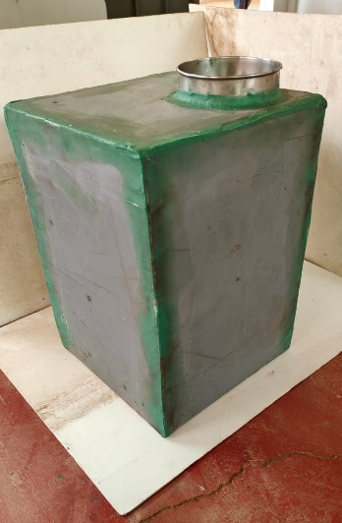 **REACTOR**:

Description: The reactor was made into a cuboidal shape with Mild Steel metal plates with dimensions

Dimensions: 10inch x 10inch x 14 inch [L X B X H]

Volume: 1400 inch

Diameter of Feedstock input gate: 4.2 inch

Fig 7.1 Reactor

* 1. **HEATING PLATE:**

Model: Heating Pad MHPS350/300

Minimum temperature: 33℃

Maximum temperature: 550℃

Minimum RPM: 200 rpm

Maximum RPM: 2200 rpm

HPS unit:

1. Minimum Temperature: 20℃
2. Maximum Temperature: 238℃
   1.  **GAS PIPELINE:**

Description: The gas pipeline acts as a condenser for our setup where it is coiled in the shape of spiral in order to increase the effectiveness of condensation.

Metal: Copper (Cu)

Diameter of copper coil: 0.25 inches

Length Condenser coil 1: 8 inches

Length Condenser coil 2: 10 inches

Total length of copper pipe used: 200 inches Fig 7.3 Copper Coil

* 1. **CONDENSER:**

Diameter of condenser: 2.5 inches

Length of 1st condenser: 12 inches

Length of 2st condenser: 12 inches

Total length of copper pipe used inside condenser: 55 inches

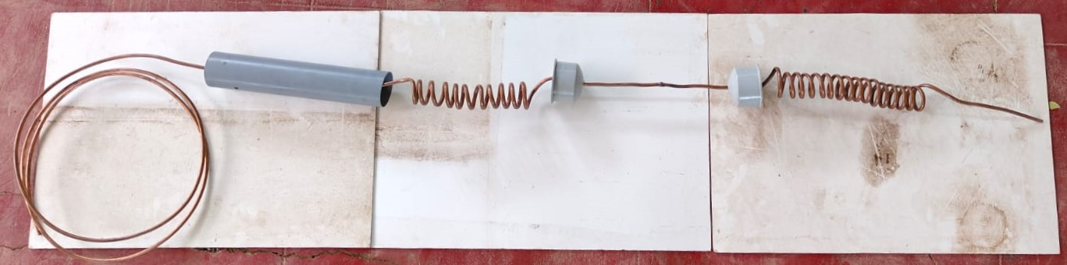

Fig 7.4.1 Double Condenser of our setup

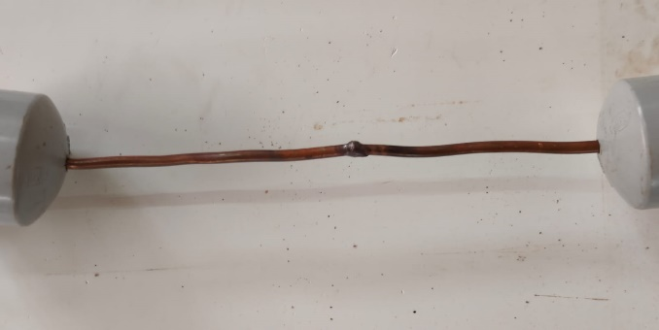

Fig 7.4.2 Gas welding of first and second condenser

1. **CAD DIAGRAM**

CAD diagrams are computer-generated visuals used in design and drafting. They find applications in engineering, architecture, manufacturing, and other industries. These diagrams are created using dedicated software for precise and detailed representations. With the help of AutoCAD Software, we were able to design our pyrolysis setup.

* 1. **REACTOR**

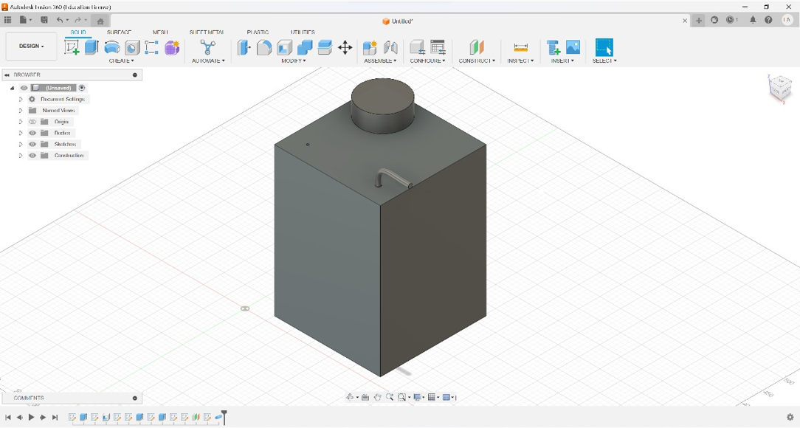

Fig 8.1.1 Imperial view of our Reactor

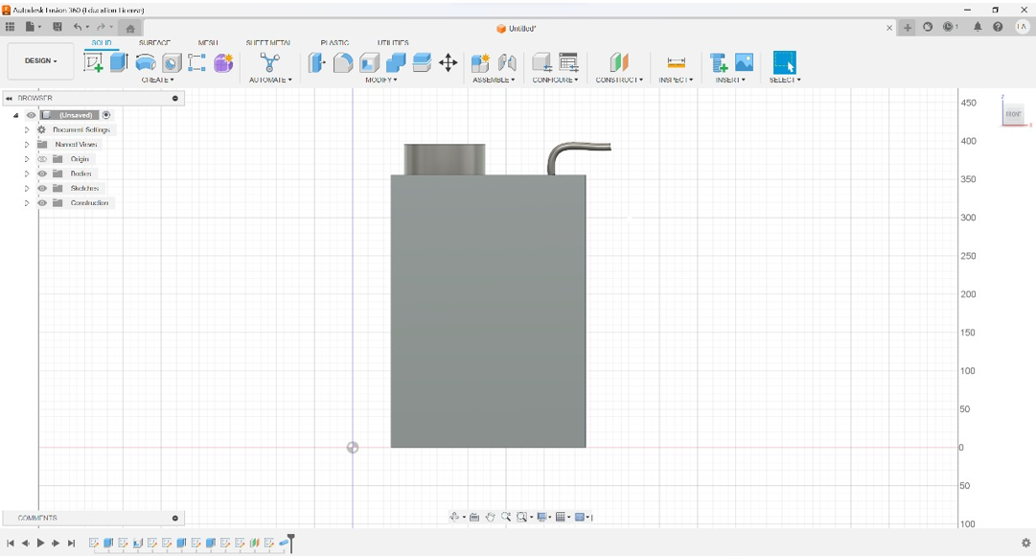

Fig 8.1.2 Side view of our reactor

* 1. **CONDENSER**

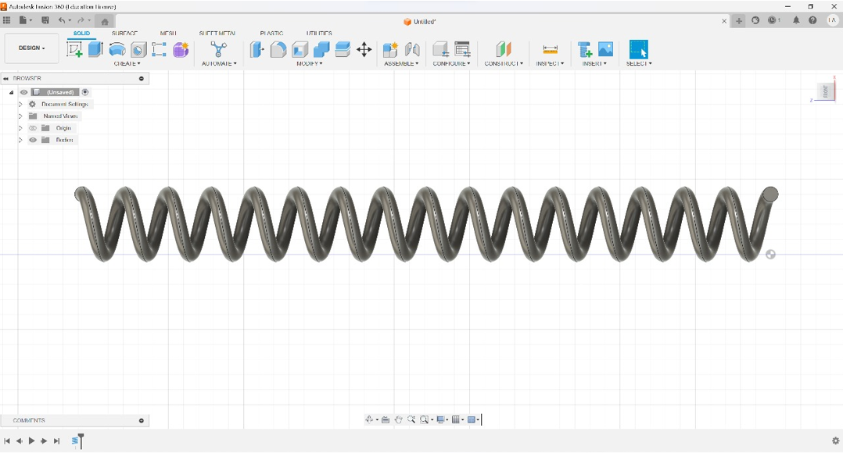

Fig 8.2.1 Side view of Copper spiral

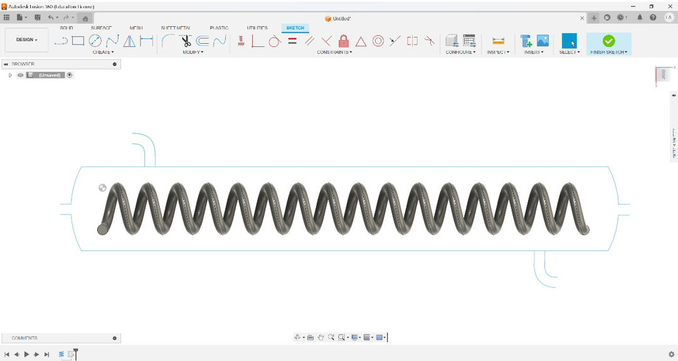

Fig 8.2.2 Side view of Copper spiral inside the condenser

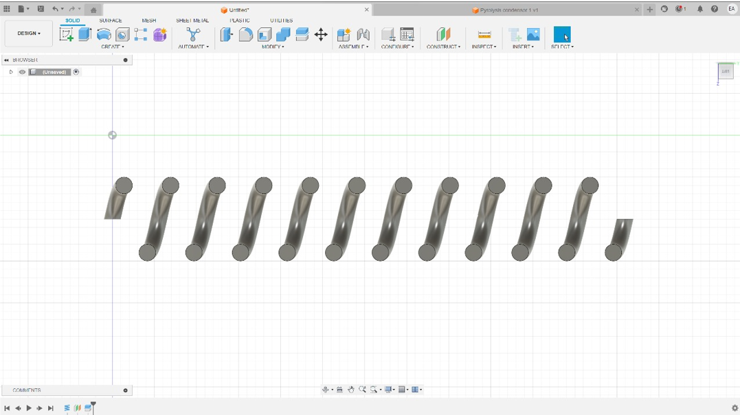

Fig 8.2.3 Vertically dissected Copper spiral

1. **WORK METHODOLOGY**

1. Reactor:

The reactor is the Key part of the plastic pyrolysis process. In this chamber, plastic waste undergoes a thermal decomposition process known as pyrolysis. Pyrolysis occurs in the absence of oxygen, preventing combustion.

The first step involves preparing the feedstock, which can be various organic materials such as biomass, plastic, or rubber. The feedstock may need to be shredded or processed to achieve a uniform size for efficient pyrolysis

The temperature range can vary based on the type of feedstock and the products desired. Typical temperatures for pyrolysis range from a few hundred to over a thousand degrees Celsius.

As the temperature rises, the organic material undergoes thermal decomposition. In the absence of oxygen, the material does not combust but instead breaks down into gases, liquids (bio-oil or pyrolysis oil), and solid char

The liquid fraction, often referred to as bio-oil or pyrolysis oil, is condensed and collected. This liquid can have applications as a fuel or as a feedstock for chemical processes.

2. Double Condenser:

The double condenser is a critical element in the recovery of valuable products generated during pyrolysis. After the plastic is broken down in the reactor, the resulting gases (vapours) need to be condensed back into liquid form. Usage of double condenser improves the efficiency.

3, Water Motors:

Water motors, or water-cooling systems, play a key role in maintaining the efficiency of the condensation process in the double condenser. Water is circulated through the condenser to absorb the heat released during the condensation of pyrolysis gases. This cooling process helps ensure that the gases fully condense into liquids, enhancing the recovery of valuable products. Proper control and monitoring of the water flow and temperature are essential for optimizing the condensation process and overall system performance

Typically, a condenser consists of a series of tubes or coils through which a cooling medium, such as water, circulates. As the hot gases pass through the condenser, they release heat energy, causing them to condense into liquid form. The use of a double condenser enhances the cooling efficiency, maximizing the recovery of valuable pyrolysis oil.

The remaining solid char or biochar, which consists of the carbon-rich residue from the pyrolysis process, is collected. Biochar has applications in agriculture and environmental remediation.

Gases produced during pyrolysis, such as syngas or other hydrocarbons, are collected. These gases can be used for various purposes, including energy generation.

4.. Oil Collector:

Once the pyrolysis gases are condensed, the resulting liquid products, including pyrolysis oil, are collected in the oil collector. This is a crucial step in the process, as it separates and gathers the valuable liquid products for further use. The collected pyrolysis oil can be a versatile resource, finding applications as a fuel or as a feedstock for various industrial processes.

This process is fundamental in converting plastic waste into valuable products, such as pyrolysis oil.

.

1. **FACTORS AFFECTING PYROLYSIS**

The major factors influencing the plastic pyrolysis process chemical composition of the feedstock, cracking temperature and heating rate, reactor pressure, residence time. The Key factor influencing our pyrolysis model is double condenser mechanism.

* 1. **Chemical composition of the feedstock:** 
     1. The pyrolytic outcomes are intricately linked to the physical properties and structural characteristics of the plastics undergoing pyrolysis.
     2. Furthermore, the physical attributes of the feedstock exert a discernible influence on the pyrolytic mechanisms. Plastics can be classified, according to structural shape of polymer molecules, as linear, branched, or cross-linked.
     3. There is a significant relationship between the density and the branching intensity of polymers. In practice, pre-recycling, waste plastics may undergo potential physical contamination, introducing additional variables that impact the dynamics of the pyrolytic process and resultant products.
  2. **Cracking temperature:**
     1. Temperature stands out as a paramount operational variable, exerting dominance over the polymer materials' cracking reactions.
     2. However, it is crucial to recognize that not all polymer materials respond uniformly to temperature-induced cracking. In the realm of physics, the Van der Waals force assumes significance, acting between molecules to attract them and prevent molecular collapse..
     3. Notably, the temperature sensors' placement in different locations along the apparatus introduces significant temperature gradients.
  3. **Heating rate**
     1. Another critical thermodynamic parameter is the heating rate, denoting the rate of temperature increase per unit time.
     2. The influence of heating rate on plastic pyrolysis processes and product distribution varies across studies due to differences in pyrolysis reactor design, operating conditions (temperature and pressure), and temperature measurement locations.
     3. In the context of fast or flash pyrolysis, the heating rate signifies the temperature change of the plastic from its deposition on a hot surface to its subsequent decomposition and vaporization.
  4. **Reactor pressure:**
     1. In plastic pyrolysis, pressure plays a significant role in influencing the pyrolysis process and its outcomes. Generally, an increase in pressure can enhance the reaction rates in pyrolysis processes. Temperature and pressure are often interrelated in pyrolysis reactions.
     2. Changes in pressure can affect the temperature required for the pyrolysis reactions to occur. Higher pressure can facilitate more collisions between the molecules, leading to increased cracking of polymer chains.
     3. This, in turn, can affect the yield and composition of the pyrolysis products. Different pressure levels may favor the formation of specific products, and the overall product spectrum may vary accordingly.
     4. This can be crucial for obtaining desired output products or optimizing the process for specific applications. High-pressure conditions may require more energy input, affecting the overall efficiency and cost-effectiveness of the pyrolysis process. Researchers and engineers often conduct experiments and simulations to optimize pressure parameters for efficient and effective plastic pyrolysis processes.
  5. **Residence time:**
     1. The definition of residence time differs in various studies. In fast pyrolysis or continuous pyrolysis process, it refers to the contact time of the plastic on the hot surface throughout the reactor.
     2. However, in slow pyrolysis and batch process, the residence time means the duration from the time when feedstock plastic start to be heated to the time when the products are removed
  6. **Key factor influencing our pyrolysis model:**

**Double condenser**

The use of a double condenser in plastic pyrolysis serves specific purposes related to the condensation and collection of pyrolysis products. With better separation and collection of products, we may increase the overall yield of valuable products, such as bio-oil, which can be further processed into biofuels or chemicals. Effects of double condenser is plastic pyrolysis are:

* **Enhanced Condensation Efficiency:**

A double condenser setup provides an extended surface area for condensation, improving the efficiency of converting pyrolysis vapors into liquid or solid products. The increased condensation efficiency is particularly beneficial in capturing a broader range of pyrolysis products, including liquids and heavier hydrocarbons.

* **Product Fractionation**:

The use of two condensers allows for the separation and collection of different fractions of pyrolysis products. For instance, lighter fractions may condense in the first condenser, while heavier fractions may require the second condenser. This setup facilitates the collection of a more diverse range of products, which can be advantageous for specific applications or downstream processes.

* **Temperature Control:**

By employing a double condenser, it becomes possible to control the temperature gradient along the condensation pathway. This control is crucial for optimizing the collection of different fractions and preventing undesired reactions or re-vaporization.

The use of a double condenser in plastic pyrolysis is a design choice that balances the need for product diversity, operational efficiency, and environmental considerations. The specific benefits depend on the overall process design and the objectives of the pyrolysis system.

1. **FEEDSTOCKS**

Pyrolysis is a process that involves the decomposition of organic materials at high temperatures in the absence of oxygen. While pyrolysis can be applied to various types of plastics, not all plastics are suitable for the process, and there are considerations to take into account.Plastics can be broadly categorized into two types:

* 1. **Thermoplastics:**

These plastics can be melted and reshaped multiple times without undergoing significant chemical degradation. Examples include polyethylene (PE), polypropylene (PP), polyethylene terephthalate (PET), and polystyrene (PS). Thermoplastics are more suitable for pyrolysis because they can be melted and then broken down into smaller molecules.

E.g.: Polypropylene, Polyethylene, etc.

* 1. **Thermosetting plastics:**

These plastics undergo a chemical change during their initial curing process, making them rigid and resistant to melting or reshaping. Examples include epoxy and phenolic resins. Pyrolysis is generally less effective for these types of plastics due to their cross-linked structure, which makes them more resistant to decomposition at high temperatures.

Eg: Polyurethane, Polyester, etc.

* All consumable plastics such as HDPE, LDPE, PP, and PS can be included as feedstock in the process.
* PET and PVC are excluded because of their harmful properties.
* Pyrolysis of PET is not recommended in pyrolysis since the degradation of this plastic produces a harmful product such as benzoic acid which may disturb the performance of process equipment.
* Benzoic acid is a general sublime that could clog the piping and heat exchanger, thus need serious attention if running at industrial scale.
* Pyrolysis of PVC releases hydrogen chloride which deteriorates the fuel quality and causes damage to the equipment.
  1. **Characteristics of feedstocks:**

|  |  |  |  |
| --- | --- | --- | --- |
| PLASTIC TYPE | TEMPERATURE | MELTING POINT | DENSITY |
| HDPE  LDPE  PET  PP | 300℃ - 400℃  350℃ - 600℃  500℃  300℃ - 700℃ | 120℃ - 160℃  110℃ - 115℃  250℃ - 260℃  160℃ - 166℃ | 0.97 g/cm3  0.940 g/cm3  1.38 g/cm3  0.92 g/cm3 |

Table 11.3 Classification of plastics on the basis of temperature , melting point and density

Based on this statistical information, we have chosen High-Density Polyethylene (HDPE), Polypropylene (PP) and Polyethylene Terephthalate (PET) as our primary feedstocks due to their abundant availability and their inherent properties that contribute to high production yields

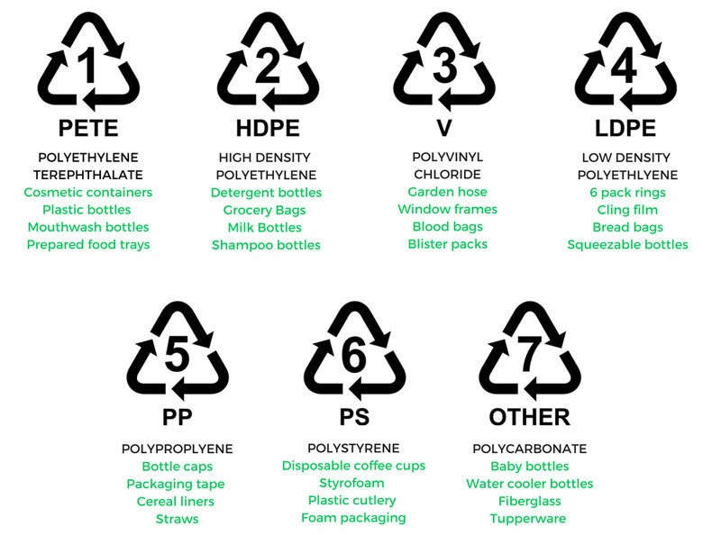

Fig 11.3 Types of plastics and its usability

1. **OBTAINED PRODUCTS AND ITS APPLICATION**

The products obtained from pyrolysis can vary depending on several factors, including the type of feedstock, the temperature and duration of the process, and the specific pyrolysis method used. However, in general, pyrolysis can yield the following main products:

* 1. **Fuel Production:**
     1. Diesel Fuel: Pyrolysis oil can be upgraded and refined to produce diesel fuel that can be used in diesel engines for transportation or electricity generation.
     2. Gasoline: With further refining, pyrolysis oil can be converted into gasoline or gasoline blend stock.
  2. **Heat and Energy Generation:**
     1. Boilers and Furnaces: Pyrolysis oil can be used as a source of heat or fuel in industrial boilers and furnaces for processes like steam generation or space heating.
     2. Electricity Generation: It can also be used in power plants to generate electricity through combustion in turbines or engines.
  3. **Chemical Feedstock:**

Pyrolysis oil may contain various chemicals that can serve as feedstock for the production of chemicals, such as aromatics or olefins, used in the chemical industry.

1. **PYROLYSIS KINETICS**

Pyrolysis is a process where organic materials are heated in the absence of oxygen, leading to decomposition. The main equations involve the chemical reactions during pyrolysis.

* 1. **Arrhenius Equation:**

The Arrhenius equation can be used to model the temperature dependence of the pyrolysis reaction rate. The activation energy (Ea) represents the energy required to break the bonds in the organic material and initiate the pyrolysis process.

k = rate constant

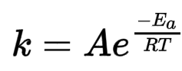 A= pre-exponential factor

e = Activation Energy

R= Universal Gas Content

T= Absolute temperature (in Kelvin)

* 1. **Heat flow capacity:**

The heat flow equation, often described by Fourier's Law of Heat Conduction, can be applied in the context of pyrolysis to understand and manage the thermal aspects of the process. Fourier's Law is expressed as:

Q = Heat energy

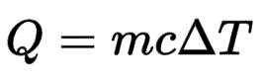 m = Mass of substance

c = Specific Heat capacity

**Δ**T = Change in temperature

**Calculation:**

Mass of Feedstock, m = 1kg

Specific heat capacity, c = 2400 J/ (kg⋅°C

Room temperature, To = 27℃

Temperature of substance, Ti = 350℃

Q = m×c (Ti-To)

Q = 1×2400(350-27)

Q = 775,200 W (or) J/s

* 1. **Overall energy Equation:**

C:\Users\A\Downloads\WhatsApp Image 2023-12-11 at 12.12.44.jpeg Q = overall energy required in the plastic pyrolysis process (kJ)

Ni = molar number of component i (mol)

Hi = enthalpy of component i (kJ/mol)

* 1. **Energy balance analysis:**

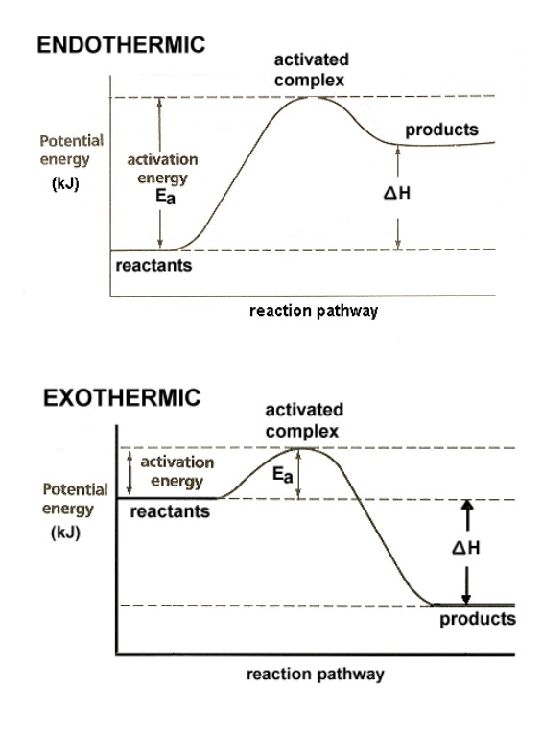In the plastic pyrolysis, energy may be consumed or released from different stages of the process and reactions. This part of work aims to quantify the energy changes throughout the pyrolysis process thus the net energy input or output can be quantified. Three parts of energy changes are considered for the reactants and resultant substances: reaction energy change (∆H), temperature change of the materials, and heat of evaporation of the products.

Fig 13.4 Graph between Potential Energy   
 and reaction pathway

1. **ADVANTAGES AND DISADVANTAGES OF PYROLYSIS**

**14.1 ADVANTAGES:**

* + 1. **Reducing Plastic Waste:** It provides a way to convert plastic waste that would otherwise end up in landfills or oceans into valuable products.
    2. **Energy Recovery:** The process can yield liquid fuels, which can be used as an energy source.
    3. **Resource Recovery:** Pyrolysis can be used to convert various organic materials, including biomass, waste plastics, and rubber, into valuable products such as biochar, bio-oil, and syngas. This allows for resource recovery from waste materials.
    4. **Energy Generation:** Pyrolysis can be employed to produce bioenergy in the form of bio-oil and syngas, which can be used as fuels for heat and power generation. This can contribute to renewable energy production and reduce dependence on fossil fuels.
    5. **Waste Reduction:** By converting organic waste materials into useful products, pyrolysis can help in reducing the amount of waste sent to landfills, contributing to waste management and environmental sustainability.
    6. **Biochar Production:** The solid residue obtained from pyrolysis, known as biochar, can be used as a soil amendment to improve soil fertility, structure, and carbon sequestration. This has potential benefits for agriculture and carbon sequestration.
    7. **Chemical Production:** Some of the products from plastic pyrolysis can be used as feedstock for chemical manufacturing.
    8. **Versatility:** Pyrolysis can be applied to a wide range of feedstocks, including biomass, plastics, rubber, and other organic materials, making it a versatile technology for waste management and resource recovery.

**14.2 DISADVANTAGES:**

* + 1. **Energy Intensive:** Pyrolysis processes often require high temperatures, making them energy-intensive. The energy input needed to initiate and sustain the pyrolysis reaction can be significant, impacting the overall efficiency of the process.
    2. **Complexity of Feedstock:** The type and composition of the feedstock significantly affect the pyrolysis process. The presence of contaminants or heterogeneous materials in the feedstock can complicate the process and may require additional pre-processing steps.
    3. **Emissions:** While pyrolysis is considered a more environmentally friendly option compared to some other waste disposal methods, it still produces emissions. Gaseous byproducts, such as volatile organic compounds (VOCs), may be released during the process, and careful management is required to minimize environmental impact.
    4. **Product Yield Variation:** The yield and composition of the pyrolysis products can vary based on the type of feedstock, process conditions, and reactor design. Achieving consistent and desired product yields can be challenging.
    5. **Char Formation:** Pyrolysis often produces a solid residue known as char or biochar. The formation of char reduces the overall yield of liquid or gaseous products and may require additional treatment or disposal.
    6. **Scale-up Challenges:** Scaling up pyrolysis processes from laboratory or pilot scale to commercial scale can pose challenges. Factors such as heat transfer, reactor design, and process control become more complex as the scale increases.

1. **ECONOMIC AND ENVIRONMENTAL IMPACT**

The economic and environmental impacts of pyrolysis can vary depending on factors such as the feedstock used, the specific pyrolysis process employed, and the end-products generated. Here's an overview of the economic and environmental aspects of pyrolysis:

**15.1 ECONOMIC IMPACTS**

* + 1. **Resource Recovery and Valorization:**

Pyrolysis can contribute to resource recovery by converting waste materials, such as biomass and plastics, into valuable products like biochar, bio-oil, and syngas. This can create economic opportunities and reduce dependence on traditional fossil resources.

* + 1. **Energy Production:**

Pyrolysis produces bioenergy in the form of bio-oil and syngas, which can be used for heat and power generation. This can contribute to energy security and provide an alternative to conventional energy sources.

* + 1. **Job Creation:**

The development and operation of pyrolysis facilities can create employment opportunities in various stages, including feedstock collection, facility construction, and operation. This can have positive economic impacts on local communities.

* + 1. **Waste Management Savings:**

Pyrolysis can reduce the volume of organic waste going to landfills, potentially lowering waste management costs for municipalities and businesses.

* + 1. **Market for Pyrolysis Products:**

The economic viability of pyrolysis is closely tied to the market demand and prices for the produced products (biochar, bio-oil, etc.). Market conditions and competition can influence the profitability of pyrolysis ventures.

* + 1. **Capital and Operational Costs:**

The capital investment and operational costs associated with pyrolysis technologies can be significant. Advances in technology and economies of scale may help reduce costs over time.

**15.2 ENVIRONMENTAL IMPACTS**

* + 1. **Greenhouse Gas Emissions:**

Pyrolysis can help mitigate greenhouse gas emissions by converting organic materials into biochar, which sequesters carbon in the soil. However, the combustion of pyrolysis products (e.g., bio-oil) can release CO2, and emissions depend on the feedstock and process conditions.

* + 1. **Air Quality:**

The combustion of pyrolysis products or emissions from the pyrolysis process itself can contribute to air pollution. However, with proper design and controls, these impacts can be minimized.

* + 1. **Land Use and Soil Quality:**

The use of biochar produced from pyrolysis as a soil amendment can improve soil fertility and carbon sequestration, positively impacting agricultural practices.

* + 1. **Waste Reduction:**

Pyrolysis reduces the volume of organic waste going to landfills, potentially alleviating environmental issues associated with landfill disposal.

* + 1. **Water Usage:**

Some pyrolysis processes may require water for cooling or other purposes. The environmental impact depends on the source of water and the efficiency of water usage.

* + 1. **Biomass and Land Competition:**

Depending on the feedstock used, there could be competition with food crops or natural ecosystems for land use. Sustainable sourcing practices are crucial to mitigate this impact.

* + 1. **Ecological Effects:**

The extraction or cultivation of feedstocks for pyrolysis can have ecological impacts, especially if not managed sustainably. Consideration of biodiversity and ecosystem services is important.

* + 1. **Contaminant Removal:**

The presence of contaminants in feedstocks, such as plastics, may pose challenges for environmental sustainability. Effective contaminant removal processes are essential.

In conclusion, while pyrolysis has the potential for positive economic and environmental impacts, careful consideration of feedstock choices, process optimization, and adherence to best practices are crucial for maximizing benefits and minimizing drawbacks. Advances in technology, coupled with supportive policies, can enhance the overall sustainability of pyrolysis processes.

1. **RESULTS AND ANALYSIS**

The selection of MS steel for the reactor components ensures not only structural robustness but also corrosion resistance, addressing the challenges posed by the corrosive nature of the pyrolysis process. This choice contributes to the longevity and reliability of the overall system. Furthermore, the design's emphasis on safety is noteworthy. The use of MS steel ensures the reactor's structural integrity under the elevated temperatures and pressures encountered during the pyrolysis process. The double condenser system adds an extra layer of safety by assisting in temperature control and preventing thermal runaway situations.

The integration of a double condenser system in the design is a key highlight, emphasizing a focus on optimizing heat exchange efficiency. The dual condenser setup enhances the cooling capacity, facilitating better control over temperature variations within the reactor. This is crucial for maintaining optimal pyrolysis conditions and maximizing the conversion of plastic feedstocks into desired end-products. The thoughtful consideration given to material selection and component configuration reflects a commitment to achieving not only operational effectiveness but also safety and environmental responsibility.

The design also considered operational aspects, ensuring continuous operation with minimal downtime. This emphasis on reliability allowed for stable and uninterrupted performance. Safety protocols were integrated into the design to enhance operator safety, reflecting a thoughtful approach to ensuring the well-being of those operating the system.

This comprehensive design approach not only guarantees a dependable and safe implementation of plastic pyrolysis but also lays the groundwork for potential future enhancements. The adaptability and scalability inherent in the design create opportunities for accommodating evolving requirements and advancements in pyrolysis technology, ensuring the setup remains versatile and responsive to changes in the waste management landscape.

1. **LIMITATIONS**

While pyrolysis offers several benefits, there are also some limitations and challenges associated with the process.

* 1. **Energetic Requirements:**

Pyrolysis requires high temperatures and significant energy input, potentially offsetting the energy gains from the produced bioenergy.

* 1. **Emissions and Air Quality:**

Depending on the feedstock and process conditions, pyrolysis can produce emissions and pollutants, requiring careful management to minimize environmental impacts.

* 1. **Complex Reaction Mechanisms:**

The diverse composition of feedstocks and the occurrence of multiple parallel reactions make it challenging to predict and control the process precisely.

* 1. **Product Yields and Composition**:

The yields and composition of pyrolysis products can vary, affecting the economic viability and desired characteristics for certain applications.

* 1. **Scale-Up Challenges:**

Scaling up pyrolysis processes to commercial scale can be complex, with issues related to heat and mass transfer, reactor design, and process control becoming more pronounced.

Addressing these shortcomings requires ongoing research and development efforts to improve efficiency, reduce environmental impacts, and enhance economic feasibility. Technological advancements and a better understanding of pyrolysis kinetics and reaction mechanisms can help overcome these challenges.

1. **CONTRIBUTATIONS**

* **Sanggit Saaran :**

The leader who lead our team in the right way to get the project work done in a very proper way. His work has been of immense importance in bringing about the entire setup stable

His focus was mainly on the Reactor part which he ensured was completely proper without any problems

* **Vishal Seshadri :**

The innovator whose hands worked so hard in the process of building up the condensers. He gave his entire focus into this project building the condenser part neatly and precisely

* **Surya :**

The researcher who researched different kinds of feedstocks finding the appropriate one which can be suitable for this project and finding the size, nature and every other aspect of the feedstock.

* **Venkatram** :

The analyser who ensured that all the parts of the setup was proper without any imbalance, leakage, also ensured whether it was completely vacuum sealed and made sure that all the process was done in a regulated manner.

* **Harivaarthan** :

The mechanic who helped us in designing the parts of the pyrolysis setup in which he researched the thermocouple part and checked about the heating part of the entire pyrolysis setup

1. **CONCLUSION**

The design of a plastic pyrolysis reactor presents a promising approach for addressing plastic waste management challenges. This report has explored the key aspects involved in the design process, including feedstock selection, reactor configuration, operating conditions, and product recovery. The proposed design offers a robust and scalable solution for converting plastic waste into valuable products such as fuels, chemicals, and char.

* 1. **Key findings of this study include**:
     1. Plastic pyrolysis offers a viable method for diverting plastic waste from landfills and generating valuable resources.
     2. The selection of the appropriate feedstock and reactor configuration significantly impacts the efficiency and product yield of the process.
     3. Careful control of operating conditions, such as temperature and heating rate, is crucial for optimizing the pyrolysis process.
     4. Effective product recovery systems are essential for capturing and utilizing the valuable products generated during pyrolysis.
  2. **Future research directions include:**
     1. Further investigation into the optimal operating conditions for different types of plastic feedstocks.
     2. Development of novel reactor designs to enhance the efficiency and selectivity of the pyrolysis process.
     3. Exploration of integrated systems that combine pyrolysis with other waste-to-energy technologies.
     4. Life cycle assessment studies to evaluate the environmental impact of plastic pyrolysis compared to other waste management options.

Overall, the design of a plastic pyrolysis reactor represents a significant step towards achieving sustainable waste management practices. By addressing the identified challenges and exploring new research directions, this technology has the potential to play a crucial role in mitigating plastic pollution and contributing to a circular economy.

Additionally, it is important to consider the following:

* The economic feasibility of the proposed design and its potential scalability.
* The environmental implications of the pyrolysis process, including greenhouse gas emissions and air pollution.
* The social and ethical implications of plastic pyrolysis, such as potential job creation and community development.

By addressing these considerations and continuing to advance the technology, plastic pyrolysis can offer a sustainable and beneficial solution for managing plastic waste and creating a cleaner future.

* 1. **FINAL DESIGN OF PYROLYSIS SETUP**

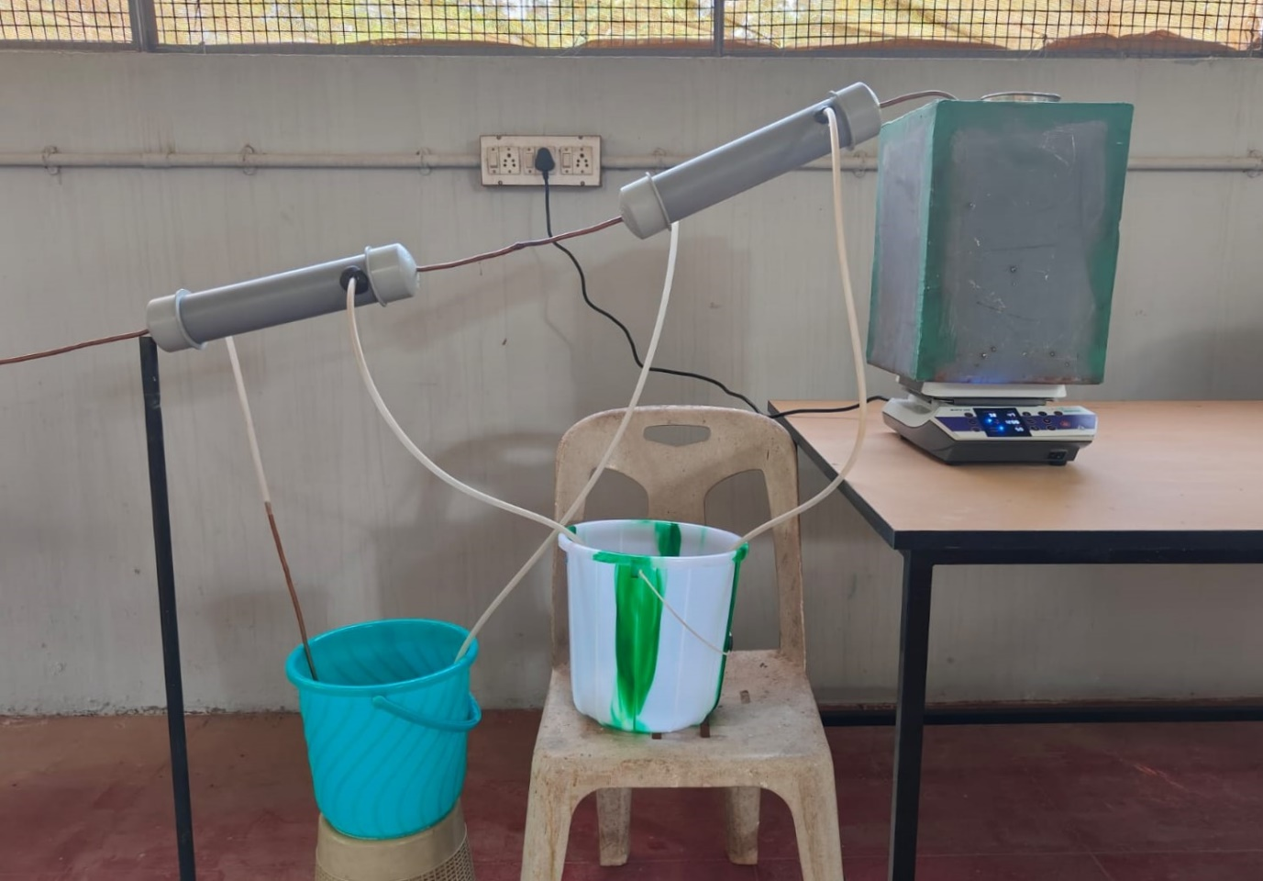

Fig 19.1 Design of plastic pyrolysis setup

1. **FUTURE SCOPE**

Several potential future enhancements could address the shortcomings and challenges of pyrolysis:

* 1. **Energy Efficiency Improvements:**

Research and development efforts can focus on optimizing pyrolysis processes to reduce energy input requirements and increase overall energy efficiency.

* 1. **Emission Control Technologies:**

Advancements in emission control technologies can help minimize the environmental impacts of pyrolysis, such as the development of better particulate matter filters and VOC abatement systems.

* 1. **Process Modeling and Control:**

Improved understanding of the complex reaction mechanisms and better process modeling can aid in precise control of pyrolysis processes, enabling more consistent product yields and composition.

* 1. **Feedstock Pre-Treatment and Management:**

Developments in feedstock pre-treatment techniques can enhance feedstock quality and consistency, leading to improved pyrolysis efficiency and product quality.

* 1. **Advanced Reactor Design:**

Innovative reactor designs, such as fluidized bed reactors or rotating cone reactors, can enhance heat and mass transfer, leading to more efficient and scalable pyrolysis systems.

* 1. **Product Upgrading Technologies:**

Research into upgrading the pyrolysis products, such as bio-oil, can improve their quality, stability, and compatibility with existing infrastructure, thereby expanding their market potential.

* 1. **Integrated Systems:**

Integration of pyrolysis with other processes, such as gasification or co-pyrolysis with other feedstocks, can enhance product yields, improve energy efficiency, and diversify the range of products.

* 1. **Catalyst Advancements:**

Research on catalyst development can lead to more efficient and stable catalysts, reducing dependency and associated costs while improving reaction rates and product yields.

Ongoing research and development efforts are dedicated to addressing the shortcomings of pyrolysis by focusing on process efficiency, environmental impacts, and economic feasibility. Advancements in technology, alongside a deeper understanding of pyrolysis kinetics and reaction mechanisms, play a crucial role in overcoming these challenges. Researchers are working on optimizing reactor designs and process control to improve efficiency. They are also exploring cleaner feedstock options and finding ways to capture and utilize byproducts. Additionally, efforts to enhance economic feasibility include developing cost-effective catalysts and scaling up pyrolysis processes for reduced production costs.

1. **TIMELINE**

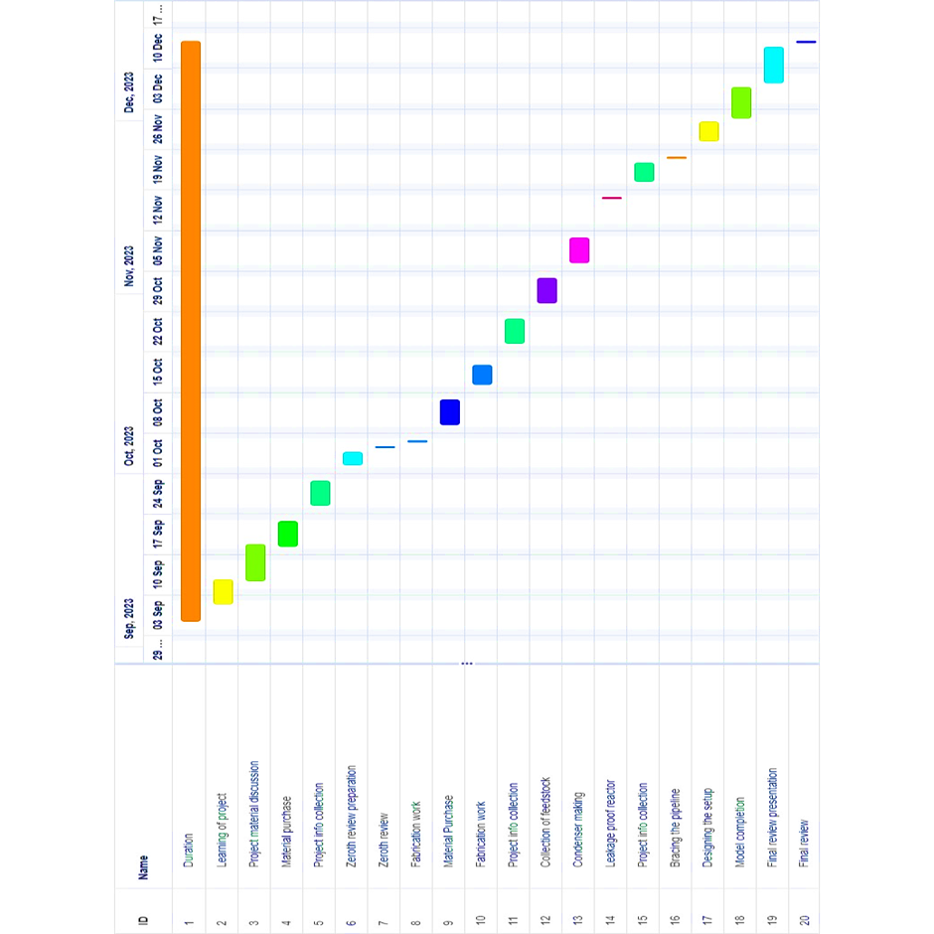

Fig 21.1 Gantt chart of our project

The project timeline helps team members to plan, track, and communicate the progress of the project. Our project mainly focused on Collecting materials, each member enlisted the items for the setup and contributed evenly. Building reactor and condenser are the time delays in our project. Enough time was provided for gas welding the two condensers.

1. **REFERENCES**
2. Moses Jeremiah Barasa Kabeyi and Oludolapo Akanni Olanrewaju "Review and Design Overview of Plastic Waste-to-Pyrolysis Oil Conversion with Implications on the Energy Transition" Industrial Engineering Department, Durban University of Technology, Durban, South Africa. <https://www.hindawi.com/journals/jen/2023/1821129/>
3. Moses Jeremiah Barasa Kabeyi ,Oludolapo Olanrewaju Durban University of Technology "Review and Design Overview of Plastic Waste-to-Pyrolysis Oil Conversion with Implications on the Energy Transition" <https://www.researchgate.net/publication/370969559_Review_and_Design_>

Overview_of_Plastic_Waste-to-Pyrolysis_Oil_Conversion_with_Implications_on_the_Energy_Transition

1. Arizal Aswan, Irawan Rusnadi, Fatria, Zurohaina, Rima Daniar Department of Chemical Engineering, Polytechnic of Sriwijaya, Palembang, Indonesia "Re-Design Pyrolysis Reactor Prototype for the Conversion of Plastic Waste into Liquid Fuel"

<https://iopscience.iop.org/article/10.1088/1742-6596/1500/1/012061/pdf>

1. Center for Biorefining and Department of Bioproducts and Biosystems Engineering, University of Minnesota, 1390 Eckles Ave., St. Paul MN 55108, United States "Pyrolysis technology for plastic waste recycling: A state-of-the-art review"

<https://www.sciencedirect.com/science/article/abs/pii/S0360128522000302>

1. Antonio Espuna, Department of Chemical Engineering, Universitat Politècnica de Catalunya, Campus Diagonal-Besòs, Barcelona, Spain "Economic and Environmental Assessment of Plastic Waste Pyrolysis Products and Biofuels as Substitutes for Fossil-Based Fuels” <https://www.frontiersin.org/articles/10.3389/fenrg.2021.676233/full>